Individual Research Project Proposal

Predictive Maintenance using Machine Learning and Time-Series Forecasting

Deelaka

RGU Number: 2237934
IIT Number: 20220275

September 6, 2025

Abstract

This project focuses on predictive maintenance using machine learning and time-series forecasting to minimize unplanned downtime in industrial sewing machines. By analyzing historical sensor data—such as vibration, temperature, and RPM—the system predicts potential machine failures before they occur. A Temporal Fusion Transformer (TFT) model is implemented to handle multivariate time-series data, capturing both short- and long-term dependencies for accurate multi-horizon forecasting. The approach enhances maintenance scheduling, reduces production interruptions, and optimizes operational efficiency. This study demonstrates how integrating deep learning with IoT-driven data can deliver actionable insights for smarter and more reliable manufacturing processes.
Contents
Abstract 1
- Introduction 3
  - Background . . . . . . . . . . . . . . . . . . . . . . . . . . . . . . . . . . . . 3
- Research Problem and Objectives 3
  - Research Problem Statement . . . . . . . . . . . . . . . . . . . . . . . . . . 3
  - Research Questions . . . . . . . . . . . . . . . . . . . . . . . . . . . . . . . . 3
  - Research Objectives . . . . . . . . . . . . . . . . . . . . . . . . . . . . . . . . 3
- Literature Review 3
  - Theoretical Background . . . . . . . . . . . . . . . . . . . . . . . . . . . . . . 4
  - Previous Studies . . . . . . . . . . . . . . . . . . . . . . . . . . . . . . . . . . 4
  - Research Gaps . . . . . . . . . . . . . . . . . . . . . . . . . . . . . . . . . . 4
  - Summary . . . . . . . . . . . . . . . . . . . . . . . . . . . . . . . . . . . . . 4
- Theoretical Framework 4
- Research Methodology 4
  - Research Design . . . . . . . . . . . . . . . . . . . . . . . . . . . . . . . . . 4
  - Data Collection Methods . . . . . . . . . . . . . . . . . . . . . . . . . . . . . 4
  - Data Analysis Techniques . . . . . . . . . . . . . . . . . . . . . . . . . . . . . 4
  - Methodology Justification . . . . . . . . . . . . . . . . . . . . . . . . . . . . 4
- Expected Contributions 4
- Timeline 4
- References 5

Introduction

Background

The apparel industry is one of the most demanding and fast-paced manufacturing sectors in the world. Each production line operates with hundreds or even thousands of sewing machines, where operational efficiency and uptime are directly tied to profitability and customer satisfaction. However, many apparel companies still rely on manual checklist methods to track machine servicing and performance, often documenting maintenance after breakdowns occur. During your internship experience in an apparel plant, it became evident that unexpected machine breakdowns cause significant production delays, lower efficiency, and sometimes even result in loss of clients due to missed delivery timelines.
When a sewing machine stops functioning, restoring it to operational status can take hours or even days, depending on the availability of spare parts and technicians. This unplanned downtime disrupts the production line flow, resulting in lower output and reduced overall equipment effectiveness (OEE). In most cases, these failures occur suddenly because traditional maintenance systems in the apparel industry lack the capability to predict when a breakdown might occur. There is currently no comprehensive system capable of identifying the root causes and early warning signals leading to these failures.
Recent advancements in Machine Learning (ML) and Artificial Intelligence (AI)—particularly in time-series forecasting—offer promising solutions to address this challenge. Predictive maintenance, powered by ML, allows the detection of anomalies and estimation of remaining useful life (RUL) of machinery using historical operational data. In this context, the Temporal Fusion Transformer (TFT) architecture emerges as a powerful model for forecasting and interpretability. It combines recurrent and attention-based mechanisms to capture both short- and long-term temporal dependencies while handling mixed data types—such as static features (needle type, last service date, fabric type) and dynamic sensor data (vibration, RPM, motor power).
By leveraging these capabilities, this project aims to design a predictive maintenance system for sewing machines that forecasts potential breakdowns using sensor data. The proposed approach not only enhances the ability to schedule proactive maintenance but also reduces downtime, increases productivity, and improves decision-making in apparel production environments. Implementing such an intelligent system can significantly transform traditional maintenance practices in the apparel industry, leading to higher operational efficiency and long-term sustainability.

Research Problem and Objectives

Research Problem Statement

2.1 Research Problem Statement
Sewing machines in apparel factories are highly utilized assets that frequently encounter unexpected breakdowns, leading to downtime and production inefficiencies. Traditional maintenance methods rely heavily on manual checklists and reactive repairs, which fail to anticipate potential failures. This lack of predictive capability causes production interruptions, delays, and financial losses.
The central problem of this study is the absence of an intelligent predictive maintenance framework capable of identifying and forecasting possible sewing machine breakdowns using historical performance and sensor data.

Research Questions
- How can machine learning and time-series forecasting be used to predict the probability of sewing machine breakdowns?
- Which parameters most significantly contribute to predicting sewing machine failures?
- How can the Temporal Fusion Transformer (TFT) architecture improve prediction accuracy and interpretability compared to traditional models (e.g., LSTM, GRU, ARIMA)?

Research Objectives
Main Objective:
To develop a machine learning–based predictive maintenance system using time-series forecasting to predict potential sewing machine breakdowns.
Specific Objectives:
- To collect and preprocess operational data such as vibration, RPM, motor torque, oil temperature, air pressure, and service history.
- To analyze and visualize historical breakdown patterns and identify key influencing factors.
- To design and implement a Temporal Fusion Transformer (TFT) model for forecasting breakdown probabilities.
- To compare model performance with baseline time-series models (LSTM, GRU).
- To evaluate the system’s effectiveness in reducing downtime and improving maintenance planning.

Literature Review

Theoretical Background
Predictive maintenance combines the concepts of time-series forecasting, anomaly detection, and supervised learning to anticipate machine failures before they occur. Time-series forecasting models like ARIMA, LSTM, and GRU have been widely used in industrial prediction tasks. However, Temporal Fusion Transformer (TFT), introduced by Google Research in 2020, provides a more advanced approach by integrating sequence modeling with attention mechanisms for interpretability and mixed feature types.
The TFT architecture includes LSTM encoders, Gated Residual Networks (GRNs), and Variable Selection Networks, which allow it to model both static and dynamic covariates effectively. Its strength lies in its ability to capture temporal dependencies and output interpretable results that show which variables influence predictions the most.

Previous Studies

Research Gaps
Most predictive maintenance studies focus on heavy industries (energy, automotive, aerospace), not on sewing machine maintenance.
Limited use of Temporal Fusion Transformer (TFT) in predictive maintenance tasks, especially in manufacturing environments.
Lack of real-time, interpretable models that combine static and dynamic features for failure forecasting.

Summary
The literature emphasizes the need for interpretable, high-accuracy forecasting models in predictive maintenance. TFT offers the most promising approach due to its explainability, scalability, and hybrid architecture, making it ideal for this project’s objectives.

Theoretical Framework
The theoretical framework for this study integrates machine learning-based time-series forecasting and predictive maintenance principles. The Temporal Fusion Transformer (TFT) forms the core predictive model, supported by data preprocessing, feature engineering, and evaluation modules.
Key components include:
- Input Layer: Time-stamped features (vibration, RPM, motor torque, etc.)
- Encoder-Decoder: Captures temporal dependencies using LSTM and GRN layers
- Attention Mechanism: Highlights important past events
- Interpretability Layer: Provides variable importance and temporal attribution
This framework supports the overall goal of transforming raw sensor data into actionable maintenance predictions.

Research Methodology
Describe the proposed research design, methods of data collection, and analysis techniques. Justify why these methods are appropriate (400-500 words). Refer to the Fig. ??
[Your methodology here - 400-500 words] Suggested structure:

Research Design
A quantitative, experimental research design will be used. Historical and real-time sensor data from sewing machines will be collected, preprocessed, and analyzed to train and evaluate the TFT model.

Data Collection Methods
Data will be gathered through IoT-enabled sensors measuring parameters such as vibration, RPM, air pressure, torque, oil temperature, and service history. These are recorded at frequent intervals (e.g., every 0.5 seconds) to ensure sufficient temporal resolution.

Data Analysis Techniques
Data Cleaning & Preprocessing using Pandas and NumPy
Feature Engineering (e.g., lag features, moving averages, scaling)
Model Training with PyTorch Forecasting’s TFT
Evaluation Metrics: RMSE, MAE, and accuracy
Visualization: Matplotlib and Power BI dashboards for interpretability

Methodology Justification
TFT was selected due to its ability to handle mixed data types, interpret complex temporal patterns, and provide explainable outputs — all essential for maintenance decision-making. It outperforms classical models like LSTM and GRU in both accuracy and interpretability.

Expected Contributions

Timeline
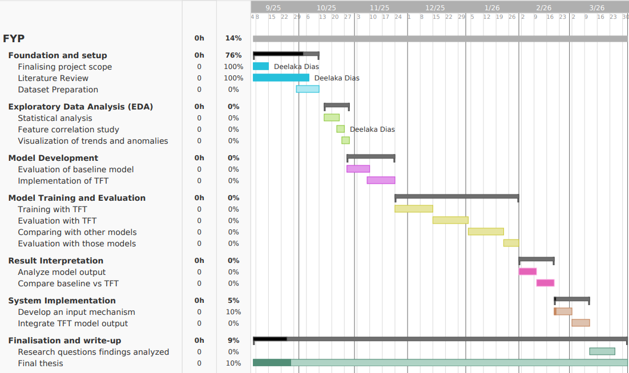

References

